**Rosanna Cubs**



**East Melbourne Fire Station Visit**

**– Tues 3rd September**

We have arranged a visit to East Melbourne Fire Station – the largest fire station in Melbourne!

DETAILS:

* **Tuesday 3rd September**
* Meet at the Hall by **6:40pm sharp.**
* Session at East Melb Fire Station is from 7:30-8:30 – so **Return** to the Hall will be around **9:15-9:30 approx.**
* ***Parent volunteers needed for transport…. Please advise   
  ( akela@rosannacubs.org or Whatsapp).*** *If we end up with too many volunteers for the number of Cubs going, some can opt not to go once that’s determined.*
* For parents providing transport, we’ll be travelling from the Hall to the Station at   
  cnr Albert & Gisborne Sts, East Melbourne – Park where you can and meet ASAP at Gisborne St front entrance – Of course, please take car with Cubs crossing roads!
* [https://maps.app.goo.gl/GAAyG8ZcBhfaR5gr8](https://maps.app.goo.gl/GAAyG8ZcBhfaR5gr8%20)
* **Full Uniform**

Regards

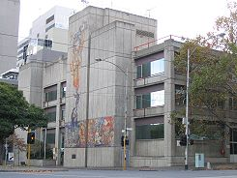

Wayne (Akela)



*This ex-Rosanna Cub is now in his late 20s, having continued through Scouts, Venturers (Queens Scout) and Rovers!*

